21.90: (a) On the axis,
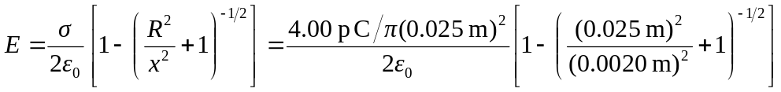
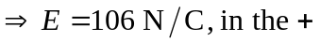x-direction.
b) The electric field is less than that of an infinite sheet 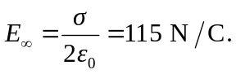
c) Finite disk electric field can be expanded using the binomial theorem since the expansion terms are small: 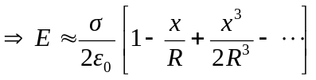 So the difference between the infinite sheet and finite disk goes like 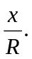 Thus:
